- Global Initiative for Academic Networks (GIAN) @ GNDU
5 days Short term course:- Cell Engineering for Biomedicine-Basics to Application dated Feb 06 -10, 2017 held at Guru Nanak Bhavan, (GNDU) by Biotechnology Deptt. GNDU, Amritsar attended by following teacher and students.

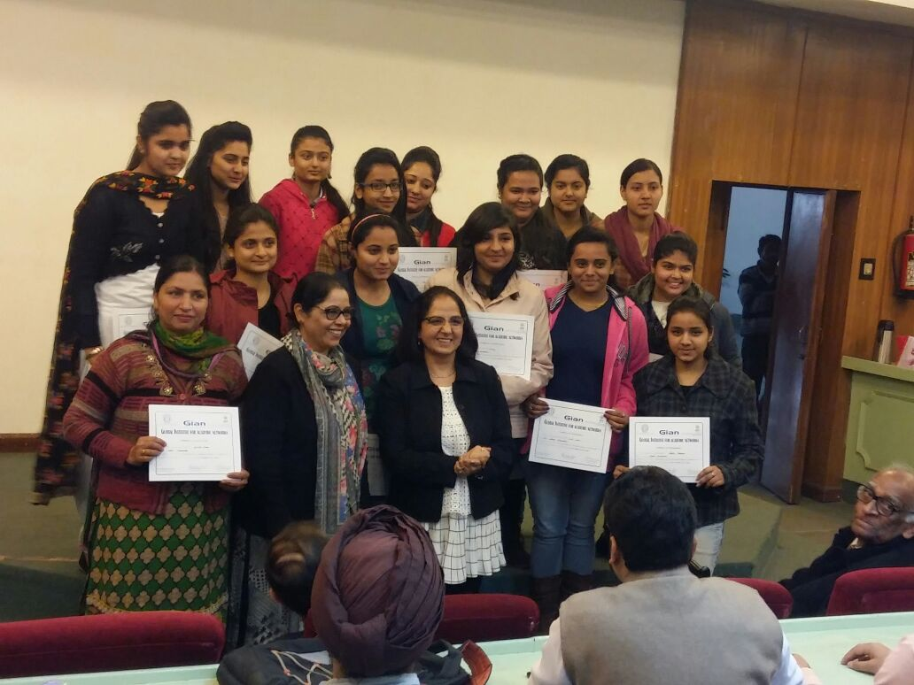

- Global Initiative for Academic Networks (GIAN) @ GNDU
Sr. No. | Name of Teacher
1. | Mrs. Sunita Verma (HOD) Zoology Deptt., SDAM College , Dinanagar
Sr. No. | Name of Student | Fathers Name | Class
 | Arushi Mahajan | Ashwani Mahajan | BSc. (Med)VI Sem
 | Priya | Prem Saroop | BSc. (Med)VI Sem
 | Diksha | Raghubir Sharma | BSc. (Med)VI Sem
 | Kirti Bala | Kishore Chand | BSc. (Med)VI Sem
 | Ishu Saini | Vijay Kumar | BSc. (Med)VI Sem
 | Navjot Kaur | Iqbal Singh | BSc. (Med)VI Sem
 | Aastha Mahajan | Inderjit Mahajan | BSc. (Med)VI Sem
 | kajal Katal | Neelam Karam Singh | BSc. (BT)VI Sem
 | Kashima Mahajan | Tilak Raj | BSc. (BT)VI Sem
 | Poonam Chaudhary | Jagjeewan Ram | BSc. (BT)VI Sem
 | Supriya Devi | Sunil Kumar | BSc. (BT)VI Sem
 | Bhanu Simran | Ranbir Singh | BSc. (BT)VI Sem

- DBT sponsored workshop on Lab safety and equipment maintenance standards at Doaba College Jalandhar, dated 20th March, 2017 attended by
Sr. No. | Name of the Lab Staff
1. | Mr. Darshan, Chemistry Deptt., SDAM College Dinanagar
2. | Mr. Surinder , Physics Deptt., SDAM College Dinanagar

- Educational trip of approx. 33 students alongwith Teachers:-Ms. Sarvpali, Mrs. Bhawna and Ms.Navneet at Hamira industries (Kapurthala) to make the students aware about various technological applications involved in biotechnology on 25th January 2017.

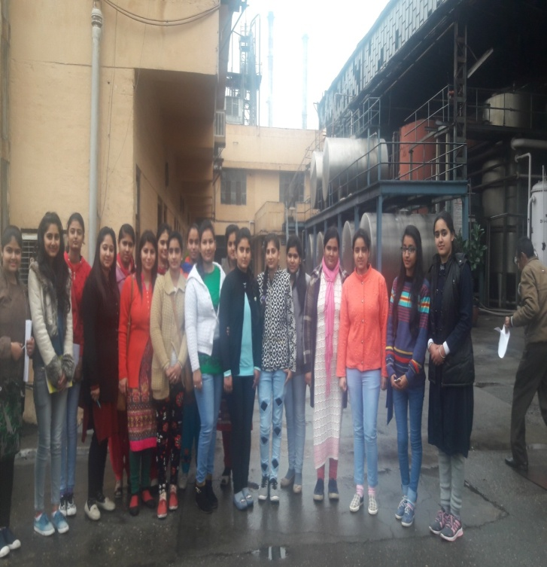

- Visits:-The students visited Emerging Life Science Department, Bhai Gurdas Library, Botanical Garden, GNDU Amritsar and Golden Temple also.
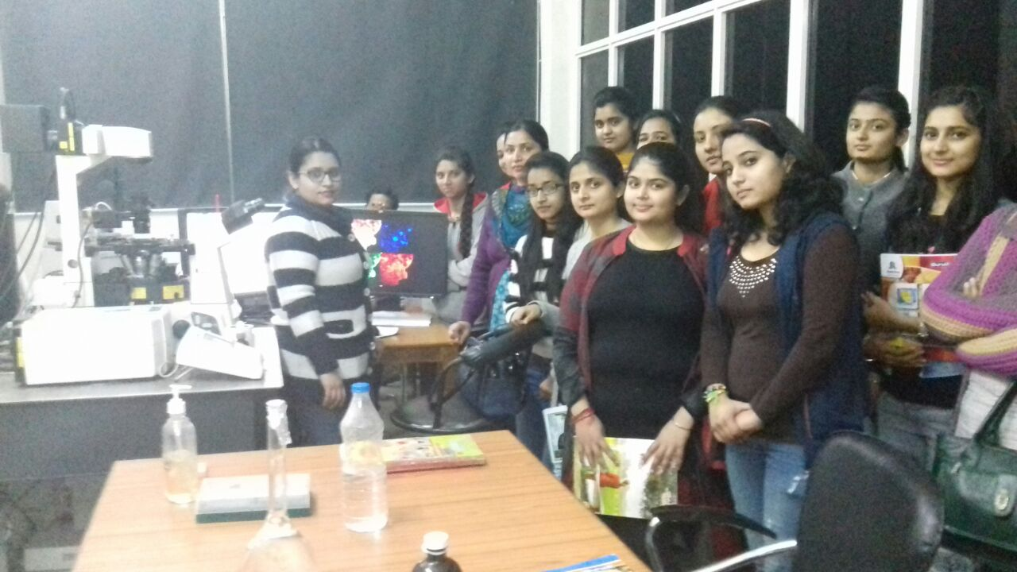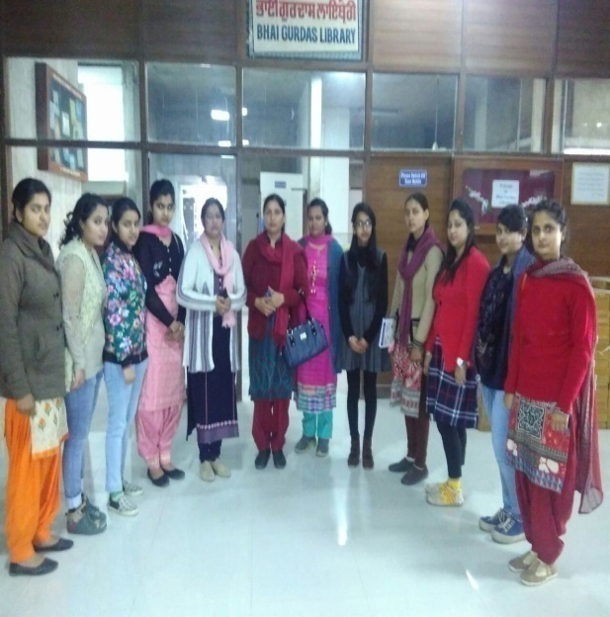
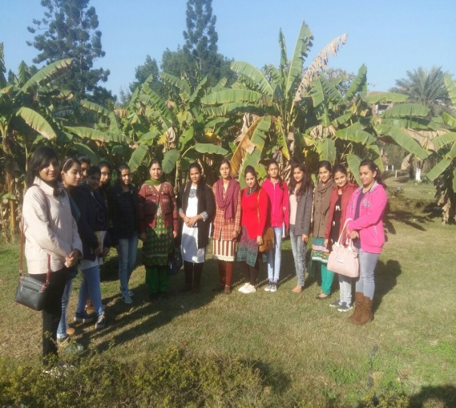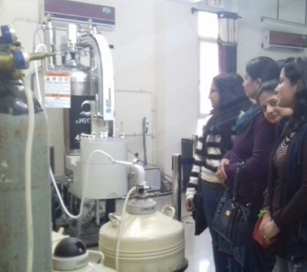

- Various Workshops:- ( 200 Students benefitted from workshops)

- Aquaculture techniques dated 21/9/2016 by Dr. Anish Dua, Department of Zoology, GNDU, Amritsar
- Genotoxicity of pesticides: potential risk for consumers dated 25th Oct., 2016 by Dr. Avinash Nagpal, Deptt. of Botany, GNDU, Amritsar
- “Importance of Chemistry in Crime scene Management”dated 26/10/2016 by Dr. G.S Sodhi, Deptt. of Chemistry, SGTBK College, Delhi
- "particle detectors" on 28/10/2016 by Dr. Bhajan Singh, Deptt. Of Physics, Punjabi University, Patiala
- Recombinant DNA technology dated 5th Nov., 2016 by Dr. Sahajpal, Deptt. of Biotechnology).
Sr. No. | Name of the Faculty invited | Topic of the Speech
 | Professor Dr. Gurcharan Kaur, Department of Biotechnology, GNDU, Amritsar. | Nature and Nurture Healthcare: Old Avenues New Approaches (5/11/2016)
 | Professor Dr. Arvinder Kaur, Department of Zoology, GNDU, Amritsar | Neutraceuticals from fish"(5/11/2016)
 | Professor Dr. Aruna Bhatia, Department of Biotechnology, Punjabi University, Patiala . | Probiotics and Phytonutrients: Potential candidates for the Immunobooster Neutraceutical formulations. (5/11/2016)
 | Professor Dr. Prabodh K Sehajpal, Deptt. of Mol. Biology & Biochemistry, GNDU, Amritsar | "Genomic Medicine: Myth or Reality"(5/11/2016)
 | Professor Dr. SS Kanwar, Deptt. of Biotechnology, Himachal Pradesh University, Summer Hill, Shimla. | "Environmental pollutants: Xenobiotic compounds and their impact" (5/11/2016)
 | Dr. Rajiv Khosla, Deptt. of biotechnology, Doaba College, Jallandhar | Molecular diagnostics(5/11/2016)
 | Dr. Akshay, Deptt. of biotechnology, BCET, Gurdaspur | Use of low cost adsorbent for removal of crystal violet dye(5/11/2016)
 | Professor Dr.Amrik Singh Ahluwalia, Department of Botany, P.U, Chandigarh. | Organic Farming (12/11/2016)
 | Professor Dr.Yash Pal Sharma, Department of Botany, University of Jammu, Jammu. | Wild mushrooms of northwest Himalayas (Jammu Kashmir ) as Organic food (12/11/2016)
 | Professor Dr.Vasudha Sambyal, Department of Human Genetics, GNDU, Amritsar. | Cancer: Synergy of genetic susceptibility and agricultural chemicals. (12/11/2016)
 | Professor Dr.Raj Kumar Rampal, Department of Environment Sciences, University of Jammu, Jammu | Vermitechnology For Sustainable Farming And Solid Waste Management. (12/11/2016)
 | Professor Dr Daljit Singh Arora, Department of Microbiology, GNDU, Amritsar. | Preservation of Microbial Cultures(12/11/2016)
 | Professor Dr. Deepak Pant, Dean and Head, Department of Environmental Sciences, Central University of HP. | Environmental Toxicology(12/11/2016)
 | Dr. Geetanjali, Department of Botany, DAV University, Jallandhar. | Mycorrhizal symbiosis: a vital player in organic farming systems. (12/11/2016)
 | Dr.Rajinder Kaur , Department of Biotechnology, BCET, Gurdaspur. | Biofertilizer production technology promoting organic farming. (12/11/2016)
 | Dr. Jagbir Singh, Punjabi Univ. Patiala | Science in current Reality(25/10/2016)
 | Dr. Amrinder, Deptt of Applied Sciences, BBSB Engineering College, Fatehgarh Sahib | Optimization Techniques in Real Life
 | Dr. G.S Sodhi, Deptt. Of Chemistry, SGTBK College, Delhi | Importance of Chemistry in Crime scene Management(26/10/2016)
 | Dr. Bhajan Singh, Deptt. Of Physics, Punjabi University, Patiala | Radiation Awareness (26/10/2016)
 | Dr. Neeraj Khare, Deptt. Of Physics, I.I.T Delhi | Superconductivity(27/10/2016)
 | Dr. A.S Ahluwalia, Deptt. Of Botany, PU, Chandigarh | Ecological Crisis and human concern with special reference to Global warming and Climate(27/10/2016)
 | Dr. Avinash Nagpal, Deptt. Of Botanical and Environmental Scinces, GNDU, Amritsar | DNA Barcoding(29/10/2016)
 | Dr. R.K Mahajan, Deptt. Of Chemistry, GNDU Amritsar | Green Chemistry(29/10/2016)
 | Dr. Anish Dua, Deptt. Of life Sciences, GNDU, Amritsar | Possibilities in the subject Zoology(23/11/2016)
 | Dr. Vandana Bhalla, Deptt. Of Chemistry, GNDU, Armritsar | From Molecular Chemistry to Molecular Machines (24/11/2016)
 | Dr. R.S Kahlon, Deptt. of Microbiology PAU, Ludhiana | Evolution of Revolution in Life Sciences(26/11/2016)
 | Dr. Arvind, Deptt. of Physics, IISER, Mohali | A glimpse in quantum world(26/11/2016)

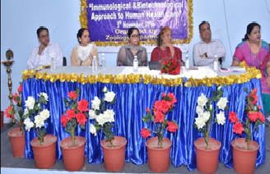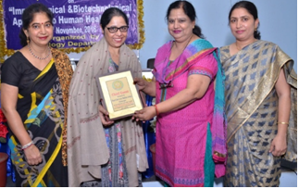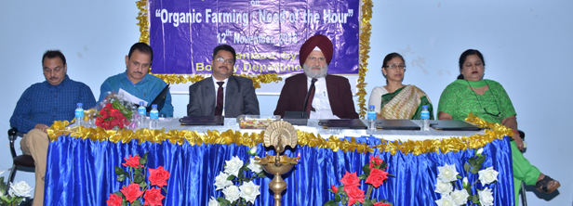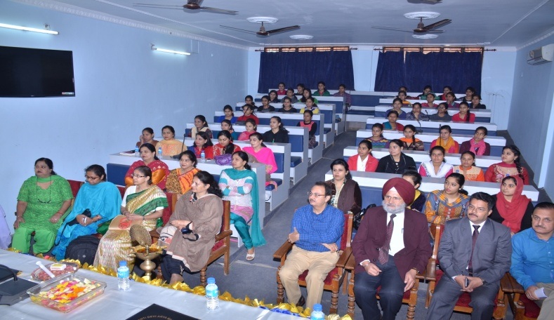
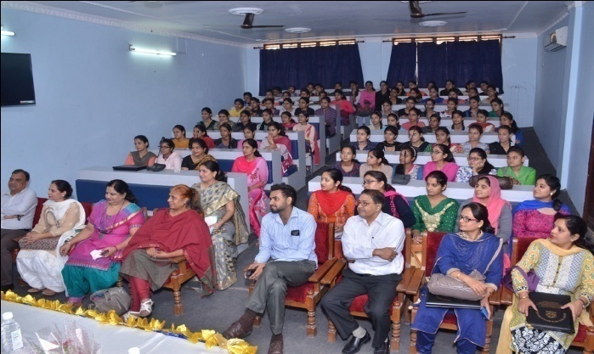

- National Science day celebration ;- 28th Feb. 2017

